**Pedagogical Models in Teachers’ Education on the Use of Technology for English Teaching: A systematic Review**

Modelos Pedagógicos para la Formación Docente en el uso de la Tecnología para la Enseñanza del Inglés: Una Revisión Sistemática

ABSTRACT

The incorporation of Information and Communication Technologies to education is a fact in the conception of future teaching and learning methodologies. In the field of English Teaching, this integration becomes an opportunity to approach students to the culture and authentic target language registers. The Remote Learning and Teaching for Emergency during Pandemic Times has revealed the potential of students and teacher to learn and adapt new technologies; however, it has also exposed the urgent necessity of designing training programs that prepare educators to incorporate digital tools into their didactics. This review revises studies that present pedagogical and methodological models to train educators in the use of ICT for teaching, specifically for English Language Teaching, and those models that intend to affect Teachers’ Digital Competence. This qualitative synthesis, which arises from publications issued from 2016 to 2022, allows the author to describe the current state of the issue and to provide recommendations for the creation of pedagogical or didactic designs to train teachers in the use of ICT for ELT.

**Keywords:** Pedagogical Models, Teachers’ Education, English Teaching, ICT, Teacher’ Digital Competence.

RESUMEN

La incorporación de las Tecnologías de la Información y la Comunicación en la educación es un hecho en la concepción de futuras metodologías de la enseñanza y el aprendizaje. En el campo de la enseñanza del inglés, esta integración se convierte en una oportunidad de aproximar a los estudiantes a la cultura y a auténticos registros lingüísticos de la lengua objetivo. La enseñanza remota por emergencia durante la pandemia ha revelado las capacidades de aprendizaje y de adaptación de estudiantes y maestros a las nuevas tecnologías; sin embargo, también ha expuesto la necesidad urgente de diseñar programas de entrenamiento que preparen a los docentes para incorporar las TIC a las didácticas específicas. Esta revisión sistemática examina estudios que presentan modelos pedagógicos y metodológicos que buscan entrenar a los educadores en el uso de la TIC para la enseñanza del inglés y modelos que persiguen afectar la competencia digital docente. El trabajo de reseña permite al autor describir el estado del conocimiento en este campo y dar recomendaciones para la creación de diseños pedagógicos o didácticos en formación docente en el uso de las TIC para la enseñanza del inglés.

**Palabras Claves**: Modelos Pedagógicos, Formación Profesoral, Enseñanza del inglés, TIC, Competencia Digital Docente.

**INTRODUCTION**

The sudden remote teaching and learning experience lived during pandemic times has revealed the urgent need of training teachers in the use of technology for education (Choi, 2021). In the field of English Language Teaching (ELT), this need becomes a demand since the integration of technology allows learners to get in touch with native speakers and target language communities as a meaningful way of developing intercultural competence and expose them to authentic language registers. Most of the models conceived for achieving the integration of Information and Communication Technologies (ICT) to education use the TPACK (technological pedagogical content knowledge) proposed by Mishra and Koehler (2006) as a reference. As this model was conceived to adapt technology to education in general, it fails at responding to the pedagogical conditions of specific areas like language teaching. Incorporating digital tools for developing language skills, for example, demands not only technological knowledge, but also and most importantly, concrete didactical strategies to adapt face-to-face classroom activities to the e-learning possibilities. These new models should also be designed from a post-method perspective (Kumaravadivelu, 1994), where classroom knowledge impacts local communities in seamless learning environments. In that sense, “there is a need to change ICT training that is primary focused on technological components” (Cabero and Barroso, 2016, p.14) and train English teachers in the use of ICT and Web tools to develop Communicative Language skills in their students (Olivares et al, 2020).

The current systematic review intends to research recent studies about Pedagogical Models (PM) or Didactical Designs (DD) for training English teachers in the incorporation of ICT to ELT, and to define the types of models that have been designed to develop Teachers’ Digital Competence (TDC) in the field of Language Teaching with the aim of justifying the formulation of a research problem that seeks to determine the influence of the implementation of a Web-based Didactical Design in TDC . To achieve this purpose, the authors present in the first part an approach to understanding critically what Pedagogical Models (PM) are, the link between ICT and ELT, and the relation of these two issues with the Development of TDC.

**UNDERSTANDING PEDAGOGICAL MODELS AND DIDACTICAL DESIGNS**

There seems not to be a clear definition of what a PM is. Several authors attempt to define it by elucidating other concepts like didactical model, didactic design, educational model, or learning design. Ocaña (2013) relates the idea of PM to the one of Didactical Model, which is a symbolic and conceptual representation that functions like a mediated scheme between the educative reality and the thought. It is made of a group of strategies and norms proposed by pedagogues to organize and lead the educational process. This model determines what, why, what for, where, when, for whom, and with whom the learning and teaching process is going to be done. Another term that this author relates to PM is Didactical Design, which is composed by a group of projects in a learning environment where individuals elaborate objectively and subjectively different learning tasks. Finally, he contrasts what an Educational and a Pedagogical model are. The first one involves more aspects of the educational field since it comprises educational policies, philosophy of education and theoretical conceptions of education, while the second one is a theoretical construct with scientific and ideological foundations to interpret, design and adjust the pedagogical reality to concrete historical needs. It implies the content, student’s development, and qualities of teaching practice. In this sense, a PM needs to: specify the essential questions about human beings every theory needs to answer, define the concept of human being that intends to educate, describe the learning sequence and the dynamic of learning, describe the type of learning experiences and curricular contents, the interactions between teacher and learners, the teaching and assessment methods and techniques. Chou (2010) also considers that PMs are required to define instructional and learning strategies, which are precisely the way the theory links with the practice. These learning strategies have to do with the didactic method, that is the way the model is put into practice in the face-to-face or online classroom. Besides, this author conceives PM as “cognitive models or theoretical constructs derived from learning theory that enable the implementation of specific instructional and learning strategies” (p. 453)

De Zubiria (2014) understands PM as “unhidden marks of our pedagogical conception” (p.25) and seems to agree with Ocaña (2013) about the terms that define what a PM is. It means that every PM assigns different functions to education depending on conceptions about human beings and society of a specific context. This is precisely what Behar (2011) intends to make clear in his definition, when she says that a PM is a set of theories or dominant explication system in any area for a period of time. In other words, she associates the term PM to “paradigm”. This idea of paradigm denotes the changing perspective about education depending on the historical period when it appears. Every model is founded after a theory or after a paradigm. For instance, the Piagetian Theory is named after the interactionist paradigm.

With regards to Digital Didactical Designs, Jahnke et al (2017) say that the term situates teaching and learning in a new perspective, where teaching more than a cognitive activity becomes an activity for learning construction. Innovation introduced by the use of technology in the classroom implies changes in three levels of didactics: the relation among students and teachers with content, the digital didactical design (how curriculum components are organized), and the curriculum development and academic staff development. For Behar (2011) these three levels constitute what he denotes a Pedagogical Architecture (PA).

Figure 1. From Pedagogical Models to Didactical Designs

EDUCATIONAL MODEL

Philosophy of education, Education Policies, a system of theoretical premises that affect the curriculum: General Law of Education, MEN policies.

PEDAGOGICAL MODEL

A theoretical construct with scientific and ideological foundations to interpret, design and adjust the pedagogical reality to concrete historical needs: PPP (Jesuist Education)

DIDACTICAL DESIGN

What, why, what for, where, when, for whom, with whom.

PEDAGOGICAL ARCHITECTURE

Pedagogical Architecture / A Design (E-LEARNING/ WEB-BASED LEARNING)

COMPONENTS OF PA

Strategies, Techniques, Sequences of Learning, Resources, Procedures

# Source: own elaboration

The figure above, elaborated based on studied theory, allow us to realize that a Pedagogical Model makes sense in its application through didactical strategies that define a Pedagogical Architecture that needs to establish concrete sequences of learning, techniques and procedures that affect the classroom. Finally, it is worth mentioning that in the corpus of the articles, few studies include a definition of what a PM or a LD is. It seems that it is taken for granted that everybody knows what they are; however, how can a PM be conceived if there is not a clear definition of what it is and its relationship with didactics?

**ICT AND ELT**

The link between technology and ELT has merged through the creation of well-known methods like CALL (Computer-Assisted Language Learning), TELL (Technology Enhanced Language Learning), BALL (Blog Assisted Language Learning) and MALL (Mobile Assisted Language Learning)

CALL is defined by Levy (1997) as “the search for and study of applications of the computer in language teaching and learning” (p.1). A proof of the incidence of technology in ELT is the growing number of publications that relate language learning to the use of technology. Fernandes (2017) states that Internet and the Web 2.0 technologies makes it possible for teachers to provide students with flexible alternatives to foster interaction, and develop language skills, especially speaking, without worrying about embarrassing classroom situations

TELL was born as an alternative to CALL. According to Wulandari & Almendo (2021), TELL refers to the use of technological tools, such as Apps, hardware, software and the internet as supplements to language learning. For example, using an electronic dictionary to look for an unknown word in a text. Some of the differences between CALL and TELL are that while in the first only desk- based computers are used for learning; in the second, technology is available in remote form at any time through different gadgets.

Ward (2004, cited by Fernandes, 2017) denominated BALL as any teaching and learning activities that involves the use of blogs as a computer-mediated platform where interactions both within and beyond the classroom among members of the learning community take place through language activities that are observable. That means that interactions are not only between the learner and the computer, but involve other members of the community.

For Shi et al. (2017), MALL is the result of the rapid development of network infrastructure, mobile network speed and usage of 3G/4G network. It has to do with the use of mobile Apps for language acquisition through the use of smartphones, pads or tablets and with the guidance of a tutor. As Cakmak (2019) states mobility refers to being connected anytime and anywhere, which implies that learners must fulfill technical and contextual requirements. The content that is delivered in the Apps for language learning must be short and supported with appropriate media types. Some of the common research in MALL involves the use of Duolingo, Instagram, and WeChat Instant Messaging.

Nevertheless, the problem seems not to be the existence of the methods, but teachers’ capacity and disposition to adapt and adopt this technology to language teaching didactics, the rapid changes in technology generation that demands constant updates through the design and implementation of programs that prepare teachers for each new challenge, and the emphasis made in the training programs to the technological component (Cabero, 2014; Cabero & Marín, 2014; Guerra, González, & García, 2010; Gutiérrez, 2014; Hechter & Vermette, 2013; cited by Cabero J. & Barroso J., 2016)

This tendency to focus training programs on technological knowledge assumes that educators already manage the content and the pedagogical knowledge; however, the latter becomes an obstacle when teachers attempt to implement the same didactical strategies, they use in the physical classroom to a virtual learning classroom. The SAMR Model (Puentedura, 2014), although not originally created for ELT, elucidates the process of changing traditional classrooms by introducing digital tools. The four stages in the adoption of technology established by this method helps understanding the possible didactical adjustments a teacher is required to make when adopting technology. For instance, introducing changes to the traditional pen and paper activity called “Find Someone Who” enables students not only to ask questions to their classmates, but takes them to use WhatsApp to interact with students worldwide by voice or text messages according to the communicative skills the English teachers intend them to practice. Nonetheless, the SAMR Model does not specify methodological procedures when training teachers for these transitions.

**DIGITAL COMPETENCE OR DIGITAL SKILLS**

To understand what DC and TDC is, it is necessary to locate the concepts in their theoretical framework. Both concepts along with Mediatic Competence belong to a most ample one, which is Information Literacy (IL). For Horton (2008), IL is a means to “empower people in all walks of life to seek, evaluate, use and create information effectively to achieve their personal, social, occupational and educational goals” (p.5) Among these capacities to deal with information is the DC or Digital Skills. UNESCO (2018, March 15) defines them as a range of abilities to use digital devices, communication applications, and networks to access and manage information. In this way, TDC has to do strictly with all those skills, attitudes and knowledge required for teachers in a digital world (Cabero-Almenara et al., 2017; Marqués, 2014, cited in Cabero-Almenara & Palacios-Rodríguez, 2020).

The European Framework for the Digital Competence of Educators (DigCompEdu) assumes that educators are the role models of DC since they need to be professionally and personally equipped with competences that are transferred to students in a form of critical and creative use of technologies. This framework comprises six areas expressed in 22 competences (Punie & Redecker, 2017)

After exploring and defining the relations between the above concepts, the question that remains is: What types of models have been designed to develop TDC in the field of Language Teaching?

**METHODOLOGY**

**OBJECTIVE OF THE CURRENT STUDY**

The expertise in the management of digital resources has been gained mostly by teachers’ initiative or need, as it has been demonstrated in the emergency remote teaching during pandemic times. There is a need to develop PMs or designs that, not only allow the integration of the three types of knowledge proposed by three TPACK Model, but models that emphasize the pedagogical component, through structured didactical procedures that establish clear learning sequences, use of resources, interactions of learning actors and effects on the learning communities. That is the reason why these two questions emerge: RQ1. Are there any pedagogical or methodological models for training English teachers in the incorporation of ICT to ELT? If so, what types of pedagogical or methodological models have been created? RQ2. What types of models have been designed to develop TDC in the field of Language Teaching?

The results of this systematic review will allow us to confirm if it is valid to formulate a research problem that intends to determine the effects of a pedagogical model in TDC that incorporate digital tools to ELT.

**SAMPLES**

Considering that the aim of the current systematic revision is to identify the existence of pedagogical or methodological models for training English teachers in the incorporation of ICT to ELT, and the types of models designed on TDC in the field of LT, definitions of the corpus of study sought to identify scientific articles, revised by peers and indexed in high qualified data bases. Web of Science (WOS) and Scopus were accessed by using the following entry words: ``Pedagogical OR Didactical Models”, “English Language Teaching or ELT”, and “Teachers’ Digital Competence”.

The raw results were organized by using Biblioshiny Software from Bibliometrics and guided by the Prisma Protocol. (See figure 1 PRISMA Flowchart). Most of the articles (2,900) from the raw results were discarded because the models that they describe belong to other knowledge areas different from language teaching or teaching in general or technology education or because they did not describe a pedagogical model or learning design.

The scientific publications (WOS: 25 and Scopus: 23) were chosen taking into account these criteria:

**Thematic**: Studies focused on describing or designing models for the incorporation of ICT to ELT in teaching training programs and/or for the development of TDC

**Impact:** Studies in the form of articles published in high impact journals

**Area of knowledge:** Education Educational Research, Education Scientific Disciplines

**Publication Dates:** Studies published between 2016 and July 2022.

**Languages:** Spanish and English

Figure 2. Selected Articles in WOS and Scopus PRISMA Flowchart.

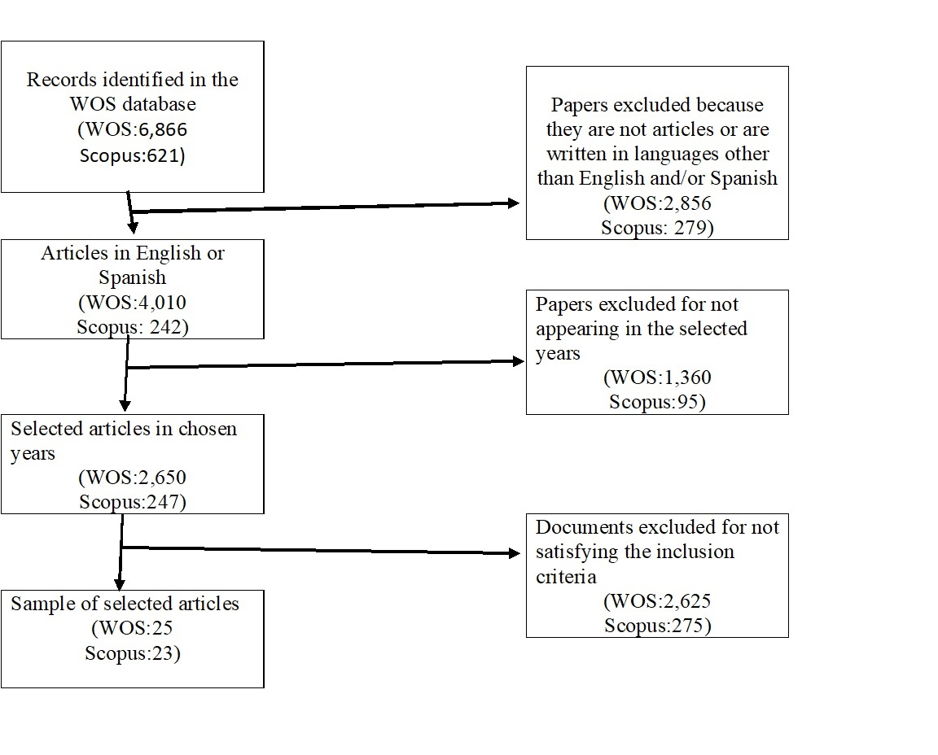

# Source: Author's own elaboration using Prisma Flow Chart.

**ANALYSIS CRITERIA**

Once the searches were refined by applying the described criteria, the results were exported from Biblioshiny to Excel and organized according to the following criteria: title, country, author, key ideas and classification, as shown in Table 1 and 2. The classification of articles was conducted taking into account the two research questions and the purpose of the models described in the articles. Group 1 includes models for the incorporation of technology to education in general, group 2 are models to develop innovation and creativity through the use of technology, group 3 are models to find out acceptance of motivation towards the use of technology, group 4 are models related to incorporation of technology to ELT, and group 5 are models for the development of TDC.

Table 1. Selected articles and classification of the models from Web of Science.

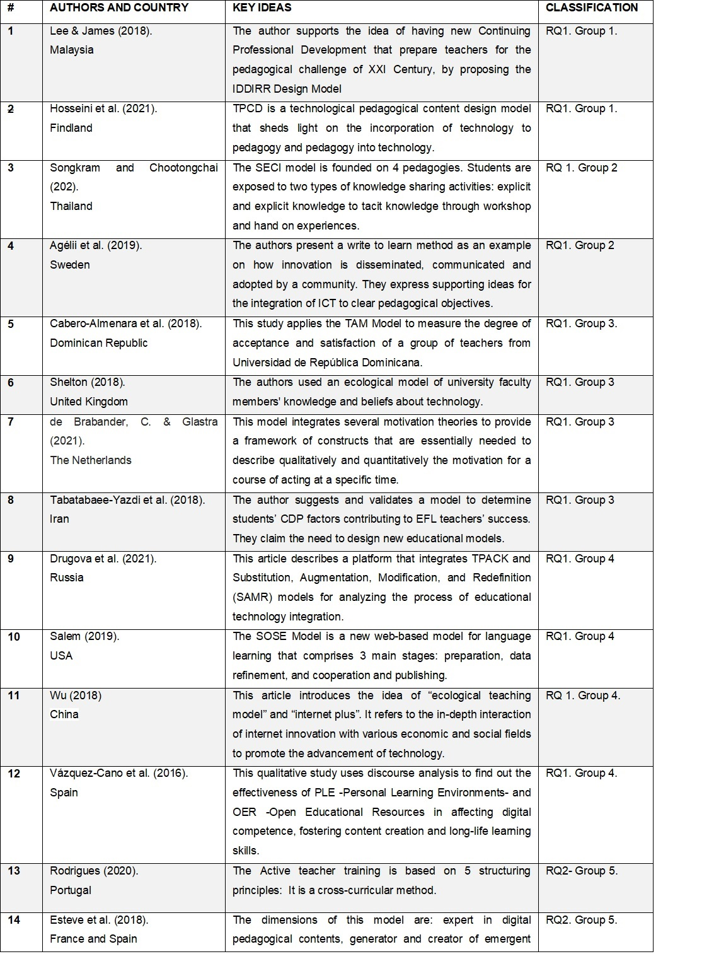

# Source: own elaboration

Table 2. Selected articles and classification of the models from Scopus.



# Source: own elaboration

**RESULTS**

**GENERAL ANALYSIS**

The analysis of the corpus shows interesting results. The main information extracted from the corpus of documents is presented in table 3

Table 3. Main Information Data.

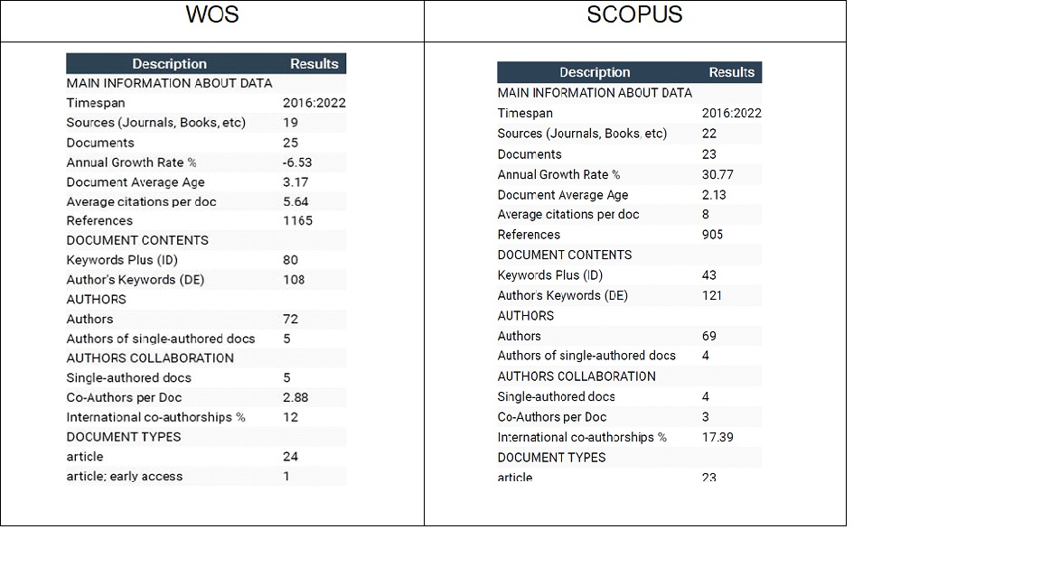

# Source: Author's own elaboration using Bibliometrix

With regards to country production over time (figure 2), the analysis from WOS shows that Spain, Malaysia and China are the countries that produce most of the articles related to the design of pedagogical proposals to train teachers in ICT use. Spain maintains an average of 8 articles from 2018 to 2022. There is not a marked tendency of specific authors that write about this theme. Scopus’ results demonstrate that Spain keeps an outstanding production, but Kazakhstan increased this rate in the last two years.

Figure 3. Country Production over time

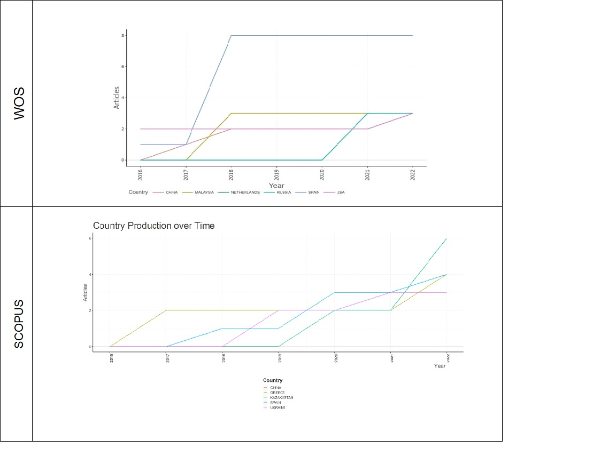

# Source: own elaboration using Bibliometrix

**ANALYSIS OF PEDAGOGICAL MODELS**

For Research question 1, the articles were classified in four groups, and for research question 2 into one group, as illustrated by table 2. Most of the articles that intend to design PM are related to pedagogy in general (56,25 %). There are only 6 proposals (12,5 %) of PM that train English teachers in the use of technology.

Table 4. Classification of articles according to purposes of the models

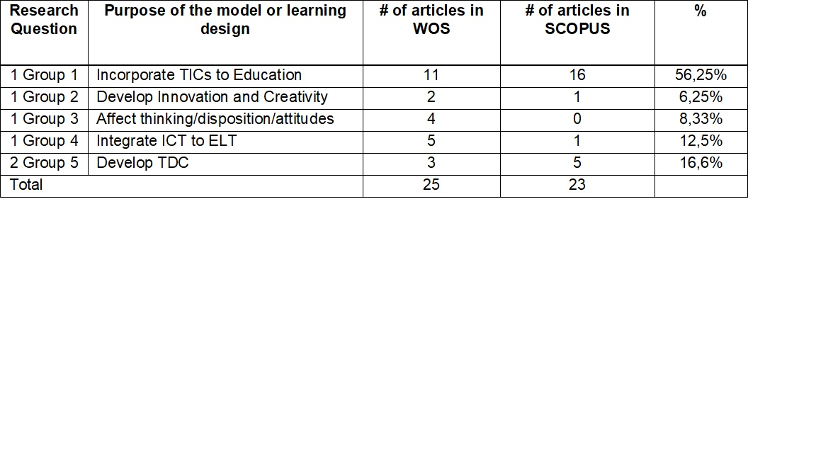

# Source: own elaboration

The following analysis includes articles from the selected corpus of 48 articles that describe clearly a Pedagogical Architecture (Strategies, Techniques, Sequences of Learning, Resources, Procedures), and that may contribute to the consolidation of a didactical design to train English teachers in the use of digital tools.

Some of the models to highlight from the first group are the IDDIRR Design Model (Introduce, Demonstrate, Develop, Implement, Revise and Reflect), the TPCD (Technological pedagogical content design), and the SMCKI Model (The Spiral Model of Collaborative Knowledge Improvement)

Lee & James (2018) propose the IDDIRR Design Model, which integrates T-PACK and PLC (Professional Learning Community) in 6 steps that define the role of the trainer and the role of students during the process.

In the same track, the TPCD Model, suggested by Hosseini et al. (2021) shed light on the incorporation of technology to pedagogy and pedagogy into technology. The authors' intention is this former idea in the sense of creating a framework for using the model for designing a website. While the TPACK model seeks to integrate technology into pedagogy and content, the TPCD proposes to integrate pedagogy into content and technology in educational and noneducational platforms. Hosseini’s model exhibits the same constraints that the TPACK model has: it is a general guide that does not elucidate concrete didactical strategies

The SMCKI Model is a five-phase pedagogical model to support the collaborative learning of a networked classroom. It focuses on democratic knowledge sharing as well as the individual, group and class level knowledge improvement processes. As can be seen this model follows principles of the CHAT Theory of Vygotsky (Yamagata-Lynch, 2010) and Constructivism. It may be beneficial in the sense that true scaffolding processes are involved when the students move in inter-intra- inter psychological procedures.

From the second group, two articles introduce models that intend to develop innovation and creativity. Songkram & Chootongchai (2020) examine the consistency of a causal model of innovation based on the SECI Model in under-graduate students in 12 universities in Thailand. The authors believe that development of creativity in students is fostered by going from socialization, externalization, combination and internalization of knowledge. The SECI model is founded on 4 pedagogies, brainstorming technique, inquiry-based learning, cooperative learning and project-based learning. The SECI Model creates awareness on the importance of knowledge assimilation from individual to group processing, from explicit knowledge to tacit knowledge. This becomes relevant at the moment of defining learning sequences in a didactical procedure.

Agélii et al. (2019) present a write to learn method as an example on how innovation is disseminated, communicated and adopted by a community. They express supporting ideas for the integration of ICT to clear pedagogical objectives. The success in the adoption of second-order change innovation depends on motivation, skill, positive learning, organization conditions, infrastructure and culture. A clear methodology with specific procedures and techniques is not described.

In the third group, three models are concerned with designs to determine the acceptance of technology used for educational aims. Cabero-Almenara et al. (2018) apply the TAM Model (Technology Acceptance Model), which was initially developed by Davies (1989), to measure the degree of acceptance and satisfaction of a group of teachers from Universidad de República Dominicana. The model considers two factors that influence an individual´s intention to use new technology: perceived ease of use and perceived usefulness. In the same token, Shelton (2018) used an ecological model of university faculty members' knowledge and beliefs about technology. This model considers contexts that influence university faculty members' thinking about technology uses. The contexts in the model are society and culture, higher education sectors, institutional context, department context and the self. A Didactical proposal in TDC development should tackle drawbacks dealing with teachers’ beliefs and contextual issues that may affect its implementation

The de Brabander & Glastra’s (2021) Unified Model of Task-Specific Motivation (UMTM) integrates several motivation theories to provide a framework of constructs that are essentially needed to describe qualitatively and quantitatively the motivation for a course of acting at a specific time. It is used by the authors to explore the readiness of teachers to learn about ICT use. Finally, Tabatabaee et al. (2018) design and validate a model to determine students’ CDP factors contributing to EFL teachers’ success. Although it is a model applied to language students, it is not committed to develop language skills but DC.

From the fourth group, the models that integrate technology to ELT, three of them are addressed to be used with students, and two are not models, but an initiative to join existing theories to implement a new mode of using technology for ELT. Only one of the articles is devoted to develop technological awareness in teachers (Yeh and Tseng, 2019). The authors do not intend to create a model, but to describe how the integration of the ADDIE Model with teachers’ lesson design affects their CALL professional knowledge.

Drugova et al. (2021) describe a platform that integrates Mishra and Koehler’s TPACK (2006) and Puentedura (2014) SAMR model for analyzing the process of educational technology integration. Vázquez-Cano et al. (2016) use discourse analysis to find out the effectiveness of PLE -Personal Learning Environments- and OER -Open Educational Resources- in affecting DC, fostering content creation and long-life learning skills. They see in Blogs’ design and implementation a unique opportunity for the development of PLEs. PLEs seems to be a valuable theoretical background to develop true scaffolding learning as it was proposed by the SMCKI Model. Attwell (2010, cited by Vasquez-Cano et al, 2016) define PLEs as “the spaces in which people interact and communicate and whose ultimate result is learning and the development of collective know-how” (p. 65). The use of blogs is seen by the authors as a unique opportunity to develop PLEs; however, PLEs are conceived as a collection of digital tools selected for learning, reflecting and collaborating with others. This is precisely what becomes interesting in this proposal since for ELT it would be very useful to establish a taxonomy of learning resources organized for the development of language skills and sorting out suggested actions for the construction of learning outcome statements and corresponding suggested activities.

One of the most interesting proposals in terms of its theoretical foundation and the response to learning in the 21st Century is the SOSE Model proposed by Salem (2019). It is a new web-based model that comprises three main stages: preparation, data refinement, and cooperation and publishing. It can be defined as an internet-based environment in which students investigate a topic, try to answer some set questions or solve a problem in collaboration with their peers. Pupils are actively involved in their own learning, take risks, learn from their errors and assume responsibility for their own learning. Another important point related with SOSE is that its main components cope with the requirements for developing hard skills (i.e., cognitive skills), and soft skills (i.e. higher-order thinking skills and twenty-first Century Skills) in addition to its positive impact on developing academic achievement and performance.

Wu’s (2018) article introduces the idea of “ecological teaching model” and “internet plus”. Internet plus refers to the in-depth interaction of internet innovation with various economic and social fields to promote the technology advance. It seems to be a policy in China. The ecological Teaching Model is completely different from traditional teaching, and uses various information tools, such as multimedia technology, network technology and speech recognition technology. It focuses on autonomous learning and cultivates students’ storage ability, multimedia skills, emotional ethics, collaborative learning ability, and self-learning ability.

Finally, three models intend to develop TDC. Two of them are addressed to develop DC in education in general and one of them to basic education.

The Active teacher training Model (ATM) projected by Rodrigues (2020) is a cross-curricular method of training that sought to integrate digital technologies in teacher education. It adopts collaborative work, is supported by socio-constructivist approach, combines a face-to-face component and autonomous work. The author says that the ATM can be used by students and teachers in any discipline; however, there are areas of knowledge, like language teaching, that demand PMs that respond to particularities like the specific integration of web tools to develop language skills and intercultural aspects.

Zimmer et al. (2022) wanted to test the efficacy of a virtual coaching model of professional development to increase teachers' digital learning competencies, based on a previous model conceived by Alaniz and Wilson (2015). This model presents cyclical moments like establishing the need, creating partnerships, targeting differentiated projects, assessing the progress and reflecting on the integration.

The Model of Holistic Competence for the Digital Word (Esteve et al., 2018) is addressed to basic education teachers, and intends to surpass the definition of Digital Teacher Competence by assuming the concept beyond an instrumental vision of technology. With regards to TDC, the authors say that educators need to have the ability of using ICT to enrich classical didactic models that respond to students learning needs (p. 108) They also insist on the idea of using Design-based Research (DBR) or Educational Design Research (EDR) to assume research as a teaching practice (p.110).

This model adds new components that none of the models mentioned above include explicitly: the use of technology for expanding family relations, students’ background, and the social commitment perspective. This remarkable relation with the community gives sense to the use of technology to foster local values and impact local communities, which has been a claim of the Pedagogy of the Oppressed (Freire, 1970), ELT post-method theory (Kumaravadivelu, 1994) and Community-based Pedagogies (Sharkey, 2012)

**DISCUSSION AND IMPLICATIONS**

The original search carried out in both data bases, showed a result of 7,487 articles that contained the proposed key words; however, only few of these studies focused strictly on designing PM for training English teachers in the incorporation of ICT to ELT and developing their DC. Besides, these articles fail at describing clearly what a PM or a PD is. It is taken for granted that everybody knows what they are; nevertheless, most of these proposals are not founded on solid learning approaches that support their creation, or fail at explaining clear didactical procedures to land the theory to the physical or virtual classroom. Most of the research studies take the TPACK as a base for the development of new models to train teachers in the use of ICT, being the technological knowledge the one that is prioritized.

The selected sample for this study shows a 2,65 average age, there are 141 authors, and only 9 articles were written by individual researchers. Spain, Malaysia,China and Kazakhstan have produced most of the articles in the target knowledge field, being Spain the one that maintains an average of 8 articles from 2018 to 2022, and Kazahistan increased its rate to 6 articles in the last year

With regards to the first research question, the answer has several edges. First of all, 48 articles include the word model or design. From these 48, 27 models have to do with the incorporation of technology to pedagogy in general, three are models that develop innovation and creativity, four intend to affect students or teachers’ thinking, acceptance or motivation about technology for educational purposes, and only six are models for technology integration to ELT. From these six models, it is worth mentioning that the SOSE Model; although it was not initially conceived to train teachers exclusively, is interesting not only because it is founded on contemporary teaching and learning theories to develop XXI Century competencies in students, but also because it presents clear methodological and didactic procedures. Furthermore, the Ecological Model targets a crucial issue in adopting technology for educational purposes, especially in not developed countries: the use of OER.

The analysis of models led the author of this study to get acquainted with other learning and teaching designs that, despite not being conceived exclusively for language acquisition purposes, may become valid bases in the intention of adopting them for language teachers’ training. Among these works, it is relevant to know that the IDDIR model that defines clear roles of the trainer and the learners in the design of TPACK- based lesson plans. The SMCKI Model stands for its collaborative essence, which is one of the demands for learners in the new Century. Participants experience individual posting of ideas, interact with the members of their group (Intra group synergy) to consolidate knowledge before they move to critique in the inter group refinement. The process ends where it started: an individual reflection of own achievements through a writing activity. The use of PLEs under OER design provides insight on how to use blogs as digital tools that enables these collaborative synergies. It should be pointed out that the Holistic Model for the Digital World calls for linking school knowledge to the community. A teachers’ professional development proposal should include this component as a way to give sense to the construction of theoretical knowledge.

In relation to the Research question 2, the models found trace general guidelines to train teachers in the use of technology based on the integration of the three T-PACK knowledge, but without defining didactic procedure for classroom instruction. The results of the study, done in two of the most reliable data bases that exist, support the idea of designing PM with concrete didactic strategies for remote training of English teachers in the incorporation of ICT to ELT through the use of Web tools. Specifically, it is urgent to focus on the integration of these tools to the development of language skills from a CLT perspective and with focus on local practices that respond to the problems of communities as Kumaravadivelu (1994) alleges.

A proposal in this line should consider the following aspects taken from the analysis of this systematic review:

● A solid theoretical foundation for the learning moments as the SOSE Model presents,

● A follow-up procedure that keeps track of educational technology integration process using the SAMR Model as a reference.

● Students’ knowledge processing from individual to group interaction, and from explicit to tacit knowledge (SMCKI Model) through the use of PLEs.

● Teachers’ beliefs, disposition and motivation as context’s issues (Ecological Model)

● Multimedia web-available resources (Internet Ecological Teaching Model).

● Family relations and students’ background to foster social commitment (Holistic Model for the Digital World)

Finally, some limitations of the study were that the WOB and Scopus Searching was time-consuming since there is no appropriate software that helps processing all the data at the same time. Bibliometrix only accepts groups of 500 publications to be exported. Considering the concept of PM elucidated in the current analysis, only some of these works detail learning sequences, strategies, techniques, resources and procedures that identify them as such.

**REFERENCES**

Agélii G, A., Gronlund, Å., & Viberg, O. (2019). Disseminating digital innovation in school – leading second-order educational change. *Educ Inf Technol* 24, 3021–3039 <https://doi.org/10.1007/s10639-019-09908-0>

Behar, P. (2011). Constructing Pedagogical Models For E-learning. *International Journal of Advanced Corporate Learning (iJAC), 4*(3), 16-22. Kassel University Press GmbH. Retrieved August 5, 2022 from <https://www.learntechlib.org/p/45571/>.

de Brabander, C. & Glastra, F. (2021). The unified model of task-specific motivation and teachers’ motivation to learn about teaching and learning supportive modes of ICT use. *Education and Information Technologies*. 26. 10.1007/s10639-020-10256-7.

Cabero-Almenara, J., Gallego-Pérez, O., Puentes Puente, Á., Jiménez Rosa, T. (2018). La “Aceptación de la Tecnología de la Formación Virtual” y su relación con la capacitación docente en docencia virtual. *EDMETIC, Revista de Educación Mediática y TIC*, 7(1), 225-241, doi: <https://doi.org/10.21071/edmetic.v7i1.10028>

Cabero-Almenara, J., & Palacios-Rodríguez, A. (2020). Marco Europeo de Competencia Digital Docente «DigCompEdu» y cuestionario «DigCompEdu Check-In». *EDMETIC, Revista de Educación Mediática y TIC*, 9(1), 213-234. doi: <https://doi.org/10.21071/edmetic.v9i1.12462>

Cabero J. & Barroso J. (2016) ICT teacher training: a view of the TPACK model / Formación del profesorado en TIC: una visión del modelo TPACK, Cultura y Educación, 28:3, 633-663, DOI: 10.1080/11356405.2016.1203526

1De Zubiria J. (2014). *Los Modelos Pedagógicos: hacia una pedagogía dialogante*. Bogotá: Cooperativa Editorial Magisterio.

Cakmak, F. (2019). Mobile learning and mobile assisted language learning in focus. *Language and Technology*, *1*(1), 30-48.

Celik, T. (2021). Examination of sample course design studies performed by pre-service social studies teachers by using digital technologies.*Turkish Online Journal of Distance Education, 22*(1), 209-228. doi:10.17718/TOJDE.849910

Chaipidech, P., Srisawasdi, N., Kajornmanee, T., Chapah, K. (2022). A personalized learning system-supported professional training model for teachers' TPACK development. Computers and Education: Artificial Intelligence. 3. 100064. 10.1016/j.caeai.2022.100064.

Choi, L., & Chung, S. (2021). Navigating Online Language Teaching in Uncertain Times: Challenges and Strategies of EFL Educators in Creating a Sustainable Technology-Mediated Language Learning Environment. *Sustainability*, *13*(14), 7664. <https://doi.org/10.3390/su13147664>

Chou, C. C. (2010). Student perceptions and pedagogical applications of e-learning tools in online courses. In *Web-Based Education: Concepts, Methodologies, Tools and Applications* (pp. 524-539). IGI Global.

Dell’Aquila, E., Vallone, F., Zurlo, M.C., & Marocco, D. (2022). SG-ACCORD: Designing Virtual Agents for Soft Skills Training in the School Context. Education Sciences.

Davis, F. D. (1989), Perceived usefulness, perceived ease of use, and user acceptance of information technology, *MIS Quarterly,* 13(3), 319-340, doi: 10.2307/249008 .

Dorner, H., & Kumar, S. (2016). Online Collaborative Mentoring for Technology Integration in Pre-Service Teacher Education. *TechTrends* 60, 48–55 (2016). <https://doi.org/10.1007/s11528-015-0016-1>

Drugova, E., Zhuravleva, I., Aiusheeva, M. et al. (2021). Toward a model of learning innovation integration: TPACK-SAMR based analysis of the introduction of a digital learning environment in three Russian universities. *Educ Inf Technol* 26, 4925–4942. <https://doi.org/10.1007/s10639-021-10514-2>

Horton F.W. Jr. (2008) Understanding Information Literacy: A primer*. UNESCO*. <https://eduq.info/xmlui/bitstream/handle/11515/17980/157020e.pdf?seq>

Esteve F., Castañeda L., Adell, J. (2018). Un Modelo Holístico de Competencia Docente para el Mundo Digital. *Revista Interuniversitaria de Formación del Profesorado*, 2018, 32.1.

Fernandes, A. M. d. S. (2017). *Teachers’ perceptions of using blogs in EFL classes in portugal* (Order No. 28755731). Available from ProQuest Dissertations & Theses Global. (2587756439). Retrieved from <http://www.ujaen.debiblio.com/login?&url=https://www.proquest.com/dissertations-theses/teachers-perceptions-using-blogs-efl-classes/docview/2587756439/se-2?accountid=14555>

Freire, P. (1970). *Pedagogy of the Oppressed*. New York: Seabury Press.

Jahnke, I. & Bergström, P. & Mårell-Olsson, E. & Häll, L. & Kumar, S. (2017). Digital Didactical Designs as research framework: iPad integration in Nordic schools. Computers & Education. 113. 10.1016/j.compedu.2017.05.006.

Hosseini, Z., Hytönen, K., & Kinnunen, J. (2021). Introducing technological pedagogical content design: A model for transforming knowledge into practice. *Knowledge Management & E-Learning,* 13(4), 630–645. <https://doi.org/10.34105/j.kmel.2021.13.031>

Kumaravadivelu, B. (1994). The postmethod condition: Emerging strategies for second/foreign language teaching [J]. *TESOL Quarterly*, 28, 27-47.

Lyailya, I., Amangeldy, K., Lyailya, B., Seidaliyeva, G., Gulnara, A., & Erzhan, E. (2022). Enhancement of scientific research function of future teachers in modern education system. *Cypriot Journal of Educational Sciences*, *17*(3), 741-751.

Lee, K. W., & James, C. C. (2018). Exploring a Transformative Teacher Professional Development Model to Engender Technology Integration in the 21st Century ESL Language Classrooms. *International Journal of Computer-Assisted Language Learning and Teaching* (IJCALLT), 8(4), 13-31. <http://doi.org/10.4018/IJCALLT.2018100102>

Levy, M. (1997). *CALL: Context and conceptualization*. Oxford: Oxford University ress.

Mishra, P., & Koehler, M. J. (2006). Technological pedagogical content knowledge: A framework for teacher knowledge. *Teachers College Record,* 108(6), 1017–1054.

Nikitina, G. A. (2021). Complex competency-based model of the intending foreign language teacher. [Комплексная компетентностная модель будущего учителя иностранного языка] *Perspektivy Nauki i Obrazovania, 53*(5), 223-237. doi:10.32744/pse.2021.5.15

Ocaña, A. O. (2013). *Modelos pedagógicos y teorías del aprendizaje* ([edition missing]). Ediciones de la U. Retrieved from https://www.perlego.com/book/1621595/modelos-pedaggicos-y-teoras-del-aprendizaje-pdf (Original work published 2013)

Olivares, C., Brenes, V., & Valverde, E. (2020). R2D2: An effective model to incorporate ICTs in the EFL classroom? *Actualidades Investigativas en Educación*, *20*(1), 196-230. <https://dx.doi.org/10.15517/aie.v20i1.40098>

Pinto-Santos, A., Pérez-Garcia, A., and Darder-Mesquida, A. (2022). Formulación y validación del modelo tecnológico empoderado y pedagógico para promover la competencia digital docente en la formación inicial del profesorado. *Form. Univ..* Vol. 15(1):183-196. DOI: 10.4067/S0718-50062022000100183

Pak, N. I., Khegay, L. B., Akkasynova, Z. K., Bidaibekov, Y. Y., & Kamalova, G. B. (2021). Preservice teacher training program for working with network mega-projects.*Journal of Educators Online, 18*(2) Retrieved from [www.scopus.com](http://www.scopus.com/" \t "_blank)

Puentedura, R. (2014). *Learning, technology, and the SAMR model: Goals, processes, and practice.* Retrieved from <http://www.hippasus.com/rrpweblog/archives/2014/06/29/LearningTechnologySAMRModel.pdf>.

Punie, Y., & Redecker, C., (2017). European Framework for the Digital Competence of Educators: DigCompEdu, EUR 28775 EN, *Publications Office of the European Union, Luxembourg*, 2017, ISBN 978-92-79-73718-3 (print),978-92-79-73494-6 (pdf), doi:10.2760/178382 (print),10.2760/159770 (online), JRC107466.

Richards, J. C., & Rodgers, T. S. (2014). *Approaches and methods in language teaching*. Cambridge university press.

Rodrigues, A. L. (2020). Digital technologies integration in teacher education: the active teacher training model. *Journal of E-Learning and Knowledge Society,* 16(3), 24-33. <https://doi.org/10.20368/1971-8829/1135273>

Salem, A. A. M. (2019). Learning in a sheltered online scaffolding environment (SOSE). *Educ Inf Technol* 24, 2503–2521.

<https://doi.org/10.1007/s10639-019-09883-6>

Sharkey, J. (2012). COMMUNITY-BASED PEDAGOGIES AND LITERACIES IN LANGUAGE TEACHER EDUCATION: PROMISING BEGINNINGS, INTRIGUING CHALLENGES. *Íkala, Revista de Lenguaje y Cultura*, *17*(1), 9-13. Retrieved October 04, 2022, from http://www.scielo.org.co/scielo.php?script=sci\_arttext&pid=S0123-34322012000100001&lng=en&tlng=en.

Shelton, C. (2018) An ecological model for university faculty members’ thinking about technology*. Journal of Computing in Higher Education*. DOI: 10.1007/s12528-018-9168-2

Shi, Z., Luo, G., & He, L. (2017). Mobile-assisted Language Learning Using WeChat Instant Messaging. *International Journal of Emerging Technologies in Learning (iJET)*, *12*(02), pp. 16–26. <https://doi.org/10.3991/ijet.v12i02.6681>

Songkram, N., Chootongchai, S. (2020). Effects of pedagogy and information technology utilization on innovation creation by SECI model*. Educ Inf Technol* 25, 4297–4315. <https://doi.org/10.1007/s10639-020-10150-2>

Tabatabaee-Y., Motallebzadeh, K., Ashraf, H., & Baghaei, P. (2018). Continuing Professional Development Strategies: A Model for the Iranian EFL Teachers’ Success. *SAGE Open*. <https://doi.org/10.1177/2158244018764234>

UNESCO (2018, March 15) *Digital Skills Critical Form Jobs and Social Inclusion*. <https://shar.es/af2qhT>

Vázquez-Cano, E., Martín-Monje, E., & Larreta-Azelain, M. (2016). Analysis of PLEs’ implementation under OER design as a productive teaching-learning strategy in Higher Education. A case study at Universidad Nacional de Educación a Distancia. *Digital Education Review, 29*.

Wang, X., & Zhang, W. (2022). Improvement of Students’ Autonomous Learning Behavior by Optimizing Foreign Language Blended Learning Mode. *SAGE Open*. <https://doi.org/10.1177/21582440211071108>

Wu, B. (2018). Construction of Ecological Teaching Model for College English Course under the Background of Internet plus. *Educational Sciences: Theory & Practic*e, 18(6), 3515-3521. <http://dx.doi.org/10.12738/estp.2018.6.261>

Wulandari M., & Almendo T. (2021). *Technology for English Language Learning*. Yogyakarta: Sanata Dharma University Press

Yamagata-Lynch, L.C. (2010). Understanding Cultural Historical Activity Theory. In: Activity Systems Analysis Methods. *Springer, Boston, MA*. <https://doi.org/10.1007/978-1-4419-6321-5_2>

Yeh, H. -., & Tseng, S. -. (2019). Using the ADDIE model to nurture the development of teachers' CALL professional knowledge.*Educational Technology and Society, 22*(3), 88-100. Retrieved from [www.scopus.com](http://www.scopus.com/" \t "_blank)

Zagouras, C., Egarchou, D., Skiniotis, P., Fountana, M. (2022). Face to face or blended learning? A case study: Teacher training in the pedagogical use of ICT. Education and Information Technologies. 27. 1-29. 10.1007/s10639-022-11144-y.

Zimmer, Wendi & Matthews, Sharon. (2022). A virtual coaching model of professional development to increase teachers' digital learning competencies. *Teaching and Teacher Education*. 109. 103544. 10.1016/j.tate.2021.103544.